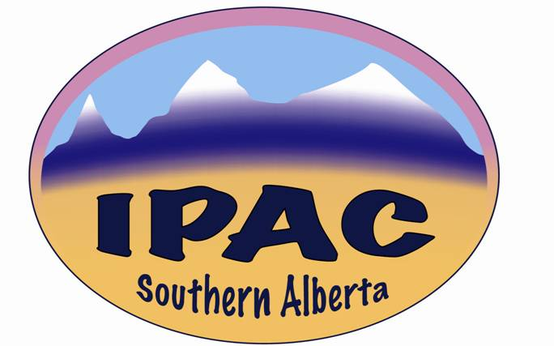

**IPAC – Southern Alberta**

**MINUTES**

**Date**: Wednesday, April 5, 2023

**Venue**: Virtual

**Time**: 13:30 – 14:30

**Present**: Jason Morris, Kristine Cannon, Obeleye Tamuno, Louis Curammeng, Dione Kolodka, Joseph Kaunda, Lorinda Stuber, Kimberly Lillington, Janeth Ty, Hitesh Patel, Jennifer Ellison, Michelle Platt, Shanthi Anchan, Ashley Shackleford, Ilona Fibich, Jennifer Happe, Josephine Kalunga, Abraham Fifen, Blanda Chow, Heidi O’Grady, Victoria Dueck, Gordon Platt, Munira PeerMohammed, Osariemhen Attamah, Sherry Qian, Suzanne Pinfield, Lemlem Ghebreyesus, Maureen Kano, Carlie King, Young Mi King, Kaethel Decker, Vanessa Bergeron (Guest Speaker).

**Absent with Apologies**: Kim Houde

Jason Morris, representing Kim Houde called meeting to order at 13:01.

**Education**

Vanessa Bergeron gave a presentation entitled: *Creutzfeldt-Jakob Disease Surveillance System.* Introduction by Jason.

**Business Component**

President’s Report (Jason Morris, for Kim Houde)

Review of minutes. They were approved by Maureen Kano and adopted.

Kudos

Toluwalope Obayomi-Davies got her CIC certification.

Rhonda DeMarco won the 2023 Sani Marc Environmental Research and Innovative Stewardship Scholarship. Her proposal was entitled*: iCAB (Improving Configuration of Ambulance Bays) to improve cleaning, disinfecting, storage of clean & sterile supplies, linens, equipment, and medications.*

Lisa Acorn (Camrose), Lorinda Stuber (Red Deer) and Leanne Whyman (Edmonton) won the 2023 Alberta Diversey/IPAC Canada scholarship.

Chapter Elections

For all offices of the executive. Please contact any of the current executive if you need more information, even if remotely interested. Submit your name, or that of an eligible member, after consulting them. Elections will be in the fall.

Funding

Members interested in attending the national conference to send their application. IPAC-SA may top up, if a member has other funding but is insufficient. Deadline for submission: **Friday April 7, 2023**. Specifics of this will be sent in a separate e-mail.

Face-to-Face Meetings

The coming June and December meetings will be face-to-face. Members encouraged to save the dates: Wednesday June 7 and Dec 6.

Important Dates

April 7 – Infection Prevention and Control Day

Some webinars on IPAC-Ca website, including Non-COVID outbreak lessons learned (April 27).

Treasurer’s Report (Kris Cannon)

The chapter still has some money that needs to be spent, ideally on education. Reminded members to apply for conference funding. The President will also be funded to the tune of $2,500 to attend the conference. This is standard practice.

Account is currently at just under $15,000. Compared to the past COVID years, it looks like we will be having some spending, which is desirable.

Accounts have not been audited since 2019. A call out made for two volunteers. Michelle Platt volunteered. Any other volunteer asked to contact Kris.

Secretary (Joseph) reminded members to send Interest Group updates.

Dione proposed that the December meeting be held off-AHS sites, like a hotel, especially if is still in a position to support. This will be looked into.

Interest Group Reports

EHIG (Gordon Platt)

On Thursday March 30, the EHIG group had a virtual quarterly meeting.  The guest speaker for the education component was Barry Hunt, former Chair of the EHIG group and an industry member (Prescientx) of IPAC Canada.

Most of Barry's expertise in environmental hygiene is focused on engineering and equipment innovation as it relates infection prevention.  His lectured (which was recorded) included a vast number of slides and provided some insight on:  new technology, new masks, LED light innovation, UV-C light for both surfaces and air ducting with very robust HVAC systems used to improve air quality, plus technology for ozonated water/sinks as part of hand hygiene and biofilm reduction in drainage pipes/traps.

The question and answer period after the lecture discussed the challenges of innovation vs. evidence based data (some sound, some lacking) applicable to each intervention.  Regardless, the infection rates within our hospitals is becoming more challenging...10 years ago, Canadian infection rates from an HAI was 1 in 10, today it is 1 in 6.  The suggestions offered within Barry's lecture provide interventional processes/technology that is best discussed through a multi-disciplinary approach to help achieve a desired infection prevention outcome.

If you have an interest in new engineered/innovation technology from an environmental hygiene perspective, please feel free to login (members only) to the IPAC Canada EHIG website portal:  <https://ipac-canada.org/environmental-hygiene-interest-group> and you will be listen to the pre-recorded lecture.

Next meeting will be face-to-face June 7, 2023. Details about venues will be communicated in due course.

There being no more items for discussion, Jason closed the meeting at 14:02.